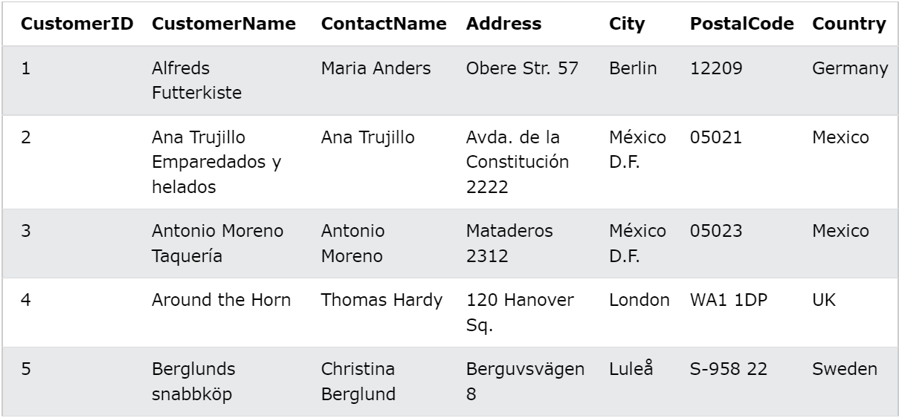

Question 1-List the number of customers in each country, ordered by the country with the most customers first.

Ans-

SELECT COUNT(CustomerID),

Country

FROM Customers

GROUP BY Country

ORDER BY COUNT(CustomerID) DESC;

Question 2-List the number of customers in each country, ordered by the country with the most customers first.

Ans-

SELECT COUNT(CustomerID),

Country

FROM Customers

GROUP BY Country

ORDER BY COUNT(CustomerID) DESC;

Question 3-Insert the missing parts in the JOIN clause to join the two tables Orders and Customers, using the CustomerID field in both tables as the relationship between the two tables.

Ans-

SELECT \*

FROM Orders

LEFT JOIN Customers

ON Orders.CustomerID=Customers.CustomerID;

Question 4-Use the BETWEEN operator to select all the records where the value of the Price column is between 10 and 20.

Ans-

SELECT \* FROM Products

WHERE Price BETWEEN 10 AND 20;

Question 5-Use the BETWEEN operator to select all the records where the value of the Price column is NOT between 10 and 20.

Ans-

SELECT \* FROM Products

WHERE Price NOT BETWEEN 10 AND 20;

Question 6-Use the IN operator to select all the records where Country is either "Norway" or "France".

Ans-

SELECT \* FROM Customers

WHERE Country IN('Norway','France');

Question 7-Set the value of the City columns to 'Oslo', but only the ones where the Country column has the value "Norway".

Ans-

UPDATE Customers

SET City = 'Oslo'

WHERE Country = 'Norway';